“AI-Based Smart Microgrid Energy Management and Load Balancing Platform”

CO-1 ASSESSMENT TOOL-1
CASE STUDY ANALYSIS REPORT
Submitted in the partial fulfilment for the course of
CSA1017 - SOFTWARE ENGINEERING
to the award of the degree of
BACHELOR OF ENGINEERING
IN
COMPUTER SCIENCE AND ENGINEERING
Submitted by
MURALI KRISHNAN N (192524090)
Under the Supervision of
Dr. LATHA


SIMATS ENGINEERING
Saveetha Institute of Medical and Technical
Sciences Chennai-602 105
July 2026

TABLE OF CONTENTS
S.No | Contents | Page No.
1 | Introduction | 1
2 | Understand the Problem Statement | 2
2.1 | Problem in Own Words | 2
2.2 | Objectives | 3
2.3 | Scope of the Problem | 4
3 | Stakeholder and Challenge Analysis | 5
3.1 | Stakeholders | 5
3.2 | Roles and Responsibilities | 6
3.3 | Challenges Faced | 7
4 | Current System Analysis | 8
4.1 | Existing System | 8
4.2 | Strengths and Limitations | 9
4.3 | Problems and Gaps | 10
5 | Proposed Software Solution | 11
5.1 | Functional Modules | 12
5.2 | Functional Requirements | 13
5.3 | Non-Functional Requirements | 14
5.4 | Software Engineering Principles | 15
6 | SDLC/Framework Justification | 16
6.1 | Agile Methodology | 16
6.2 | Justification | 17
7 | Expected Outcomes and Limitations | 18
7.1 | Expected Outcomes | 18
7.2 | Limitations | 19
7.3 | Future Enhancements | 20
8 | Conclusion | 21

1.INTRODUCTION
The growing demand for electricity and the increasing use of renewable energy sources such as solar and wind power have encouraged the adoption of microgrids in campuses, industries, and residential communities. A microgrid is a localized power system that can generate, store, and distribute electricity efficiently while reducing dependence on the main power grid.
Traditional energy management systems mainly focus on monitoring electricity usage but lack intelligent features such as demand forecasting, battery optimization, and automatic load balancing. As renewable energy sources are intermittent, these limitations often lead to energy wastage, higher operational costs, and reduced system reliability.
The proposed AI-Based Smart Microgrid Energy Management and Load Balancing Platform combines Artificial Intelligence (AI), Internet of Things (IoT), smart meters, battery storage systems, and cloud computing to provide intelligent energy management. The system continuously monitors energy generation and consumption, predicts future electricity demand, optimizes battery utilization, balances electrical loads automatically, and generates real-time reports. This improves energy efficiency, increases renewable energy utilization, reduces electricity costs, and ensures reliable and sustainable power management.
This case study analyzes the existing energy management system, identifies stakeholders and challenges, proposes a software solution based on software engineering principles, justifies the selected Software Development Life Cycle (SDLC), and discusses the expected outcomes, limitations, and future enhancements.
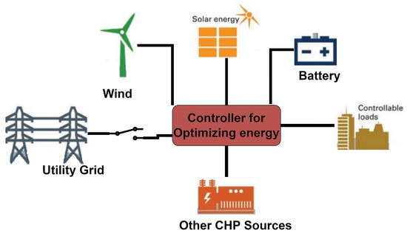

2: IDENTIFY KEY STAKEHOLDERS AND CHALLENGES
2.1 Key Stakeholders
Stakeholders are the individuals or organizations involved in the development, operation, and use of the AI-Based Smart Microgrid Energy Management and Load Balancing Platform. Each stakeholder plays an important role in ensuring the efficient operation of the system.
Stakeholder | Description
Microgrid Operator | Monitors and manages the daily operation of the microgrid.
Consumers (Users) | Use electricity supplied by the microgrid in homes, industries, or campuses.
Maintenance Team | Maintains batteries, smart meters, sensors, and other equipment.
Renewable Energy Providers | Supply electricity from solar panels, wind turbines, or other renewable sources.
System Administrator | Manages the software platform, user accounts, and system security.
Government & Regulatory Authorities | Ensure the system complies with energy regulations and environmental policies.
Management/Organization | Makes decisions regarding investment, energy planning.

2.2 Roles and Responsibilities of Stakeholders
1. Microgrid Operator
- Monitor electricity generation and consumption.
- Control battery charging and discharging.
- Ensure continuous power supply.
- Monitor system performance through dashboards.
2. Consumers (Users)
- Consume electricity efficiently.
- Monitor their energy usage.
- Report faults or abnormal power usage.
3. Maintenance Team
- Inspect and maintain electrical equipment.
- Repair faulty sensors and smart meters.
- Ensure smooth operation of batteries and renewable energy systems.
4. Renewable Energy Providers
- Supply electricity from solar and wind sources.
- Maintain renewable energy equipment.
- Ensure continuous renewable power generation.
5. System Administrator
- Manage users and access permissions.
- Maintain the software and database.
- Ensure cybersecurity and data protection.
- Perform software updates and backups.
6. Government & Regulatory Authorities
- Monitor compliance with energy regulations.
- Promote renewable energy usage.
- Ensure safety and environmental standards.
7. Management
- Review energy performance reports.
- Plan energy-saving strategies.
- Approve system upgrades and investments.

2.3 Challenges Faced by Stakeholders
Microgrid Operator
- Difficulty in balancing electricity demand and supply.
- Managing sudden changes in renewable energy generation.
- Preventing overloads and power failures.
Consumers
- High electricity costs.
- Power interruptions during peak demand.
- Limited information about energy consumption.
Maintenance Team
- Detecting equipment faults quickly.
- Maintaining batteries and IoT devices.
- Reducing maintenance costs.
Renewable Energy Providers
- Energy generation depends on weather conditions.
- Difficulty maintaining continuous power generation.
System Administrator
- Protecting the system from cyberattacks.
- Managing large amounts of energy data.
- Maintaining system availability.
Government & Regulatory Authorities
- Ensuring compliance with environmental regulations.
- Encouraging renewable energy adoption.
- Monitoring carbon emission reduction.
Management
- Reducing operational costs.
- Improving energy efficiency.
- Making informed decisions based on energy reports.
3: CURRENT SYSTEM ANALYSIS
3.1 Existing System
The current microgrid energy management system mainly focuses on monitoring electricity generation and consumption using smart meters and sensors. It collects energy data from renewable energy sources such as solar panels and wind turbines, battery storage systems, and the main power grid. Operators manually monitor the system through basic dashboards and make decisions regarding battery charging, energy distribution, and load balancing.
Most existing systems provide real-time monitoring but lack intelligent decision-making capabilities. They cannot accurately predict future electricity demand or automatically optimize battery storage and electrical load distribution. As renewable energy production depends on weather conditions, the current system often struggles to efficiently manage energy resources, resulting in energy wastage and increased operational costs.

3.2 Strengths and Limitations of the Existing System
Strengths
- Provides real-time monitoring of electricity generation and consumption.
- Supports integration of renewable energy sources such as solar and wind.
- Uses smart meters and IoT sensors for energy data collection.
- Helps operators monitor battery status.
- Improves visibility of energy usage through dashboards.
Limitations
- No AI-based electricity demand forecasting.
- Battery charging and discharging are not fully optimized.
- Load balancing requires manual intervention.
- Renewable energy utilization is not maximized.
- Limited predictive maintenance for electrical equipment.
- Higher electricity and maintenance costs.
- Limited reporting and decision-support capabilities.
3.3 Problems and Gaps in the Current System
Although the existing system provides basic monitoring, several important problems still exist:
- Lack of AI-based demand prediction.
- Inefficient battery storage management.
- Energy wastage due to poor load balancing.
- Difficulty in handling fluctuations in renewable energy generation.
- Delayed fault detection and maintenance.
- Higher operational expenses.
- Limited real-time analytics and reporting.
- Reduced reliability during peak electricity demand.
- Inability to support intelligent energy planning and optimization.
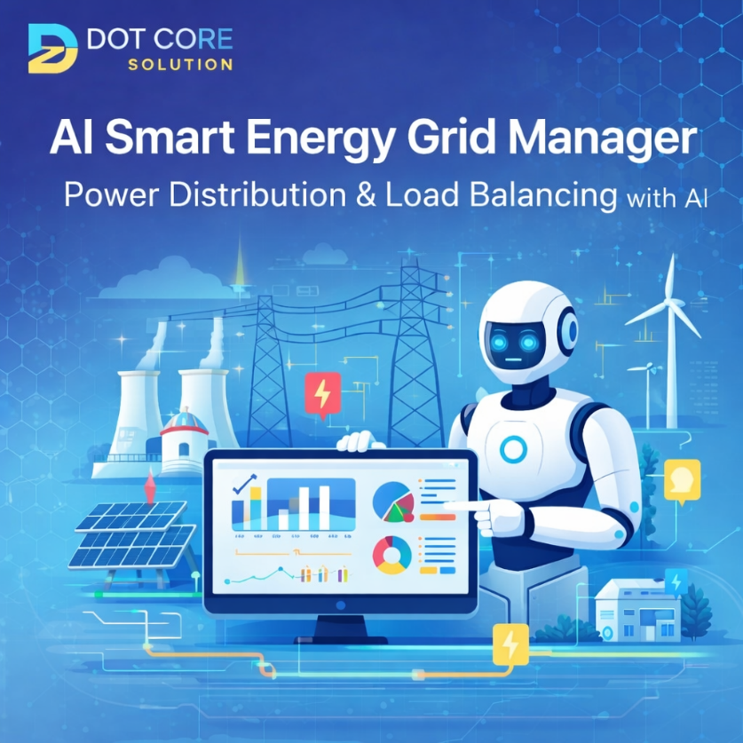
CHAPTER 4: CURRENT SYSTEM ANALYSIS
4.1 Existing System
The existing microgrid energy management system is designed to monitor electricity generation and consumption using smart meters, sensors, and basic monitoring software. It collects energy data from renewable energy sources such as solar panels and wind turbines, battery storage systems, and the main power grid. Operators use this information to monitor energy usage and manually control battery charging, energy distribution, and load balancing.
Although the system provides real-time monitoring, it has limited intelligence. It cannot accurately predict future electricity demand, optimize battery utilization, or automatically balance electrical loads. As a result, renewable energy is not fully utilized, operational costs increase, and power reliability decreases during peak demand.
4.2 Strengths and Limitations
Strengths
- Provides real-time monitoring of energy generation and consumption.
- Supports integration of renewable energy sources.
- Uses smart meters and IoT sensors for data collection.
- Helps operators monitor battery status.
- Provides basic energy usage reports.
- Improves visibility of overall energy consumption.
Limitations
- No AI-based demand forecasting.
- Battery charging and discharging are not optimized.
- Load balancing requires manual intervention.
- Renewable energy utilization is limited.
- Limited predictive maintenance capability.
- Higher operational and maintenance costs.
- Basic reporting with limited analytics.
- Less effective during sudden changes in energy demand.
4.3 Problems and Gaps
The current system has several shortcomings that reduce its efficiency and reliability:
- Lack of AI-based electricity demand prediction.
- Inefficient battery storage management.
- Energy wastage due to poor load balancing.
- Difficulty handling fluctuations in renewable energy generation.
- Delayed fault detection and maintenance.
- Increased electricity and operational costs.
- Limited real-time analytics and decision support.
- Reduced reliability during peak load conditions.
- No automatic optimization of energy resources.
- 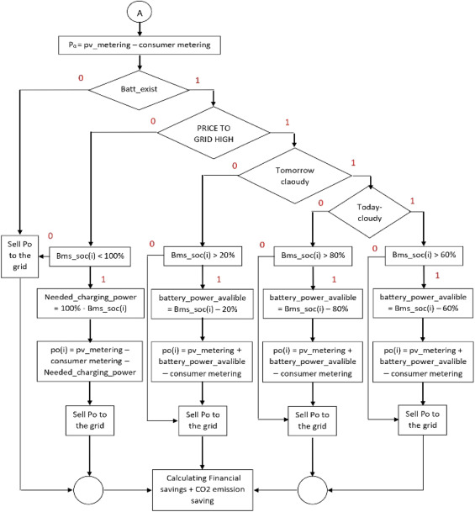

5: PROPOSED SOFTWARE SOLUTION
5.1 Functional Modules
The proposed AI-Based Smart Microgrid Energy Management and Load Balancing Platform consists of the following functional modules:
1. Energy Monitoring Module
- Monitors real-time electricity generation and consumption.
- Collects data from smart meters and IoT sensors.
- Displays live energy usage.
2. AI Demand Forecasting Module
- Predicts future electricity demand using AI.
- Analyzes historical energy data.
- Supports better energy planning.
3. Battery Management Module
- Optimizes battery charging and discharging.
- Prevents overcharging and deep discharge.
- Improves battery efficiency and lifespan.
4. Load Balancing Module
- Automatically distributes electrical loads.
- Prevents overloads and power interruptions.
- Ensures stable power distribution.
5. Renewable Energy Integration Module
- Integrates solar and wind energy sources.
- Maximizes renewable energy utilization.
- Reduces dependence on the main power grid.
6. Dashboard and Reporting Module
- Displays real-time energy information.
- Generates daily, weekly, and monthly reports.
- Provides charts and performance analysis.
7. Alert and Notification Module
- Detects faults and abnormal conditions.
- Sends alerts to operators.
- Improves response time during emergencies.
5.2 Functional Requirements
The proposed system should be able to:
- Monitor electricity generation and consumption in real time.
- Forecast future electricity demand using AI.
- Optimize battery charging and discharging.
- Automatically balance electrical loads.
- Integrate renewable energy sources.
- Generate energy performance reports.
- Display real-time dashboards.
- Send alerts during overloads or equipment failures.
- Store historical energy data.
- Provide secure user login and access control.
5.3 Non-Functional Requirements
The system should satisfy the following quality requirements:
Performance
- Process energy data quickly with minimum delay.
Reliability
- Ensure continuous and stable system operation.
Scalability
- Support additional users, sensors, and renewable energy sources.
Maintainability
- Allow easy software updates and maintenance.
Usability
- Provide a simple and user-friendly interface.
5.4 Software Engineering Principles
Modularity
The system is divided into separate modules such as monitoring, forecasting, battery management, load balancing, reporting, and user management. This makes development, testing, and maintenance easier.
Scalability
The system can be expanded by adding more IoT devices, renewable energy sources, and users without affecting existing operations.
Maintainability
The modular design allows developers to update and maintain individual components without interrupting the entire system.
Reliability
Real-time monitoring, AI-based forecasting, and automatic load balancing improve system reliability and reduce downtime.
Usability
The dashboard is designed with a simple interface, allowing operators and users to monitor energy data and reports easily.
Security
The system uses secure login, role-based access control, data encryption, and regular backups to protect sensitive information.
6: SDLC/FRAMEWORK JUSTIFICATION
6.1 Agile Methodology
The Agile Software Development Methodology is selected for developing the AI-Based Smart Microgrid Energy Management and Load Balancing Platform. Agile is an iterative and flexible software development approach that divides the project into small development cycles called sprints. Each sprint delivers a working version of the software, allowing continuous testing, customer feedback, and improvements.
Agile promotes collaboration among developers, stakeholders, and users throughout the project. Since AI models, IoT devices, and energy management requirements may change over time, Agile provides the flexibility to adapt to these changes quickly and efficiently.
6.2 Justification
Agile is the most suitable SDLC model for this project because:
- Supports changing requirements during development.
- Delivers software in small, manageable iterations.
- Encourages continuous customer and stakeholder feedback.
- Allows early testing and bug detection.
- Improves software quality through continuous improvement.
- Facilitates integration of AI, IoT, and cloud technologies.
- Reduces project risks by identifying issues early.
- Makes future enhancements and maintenance easier.
Thus, Agile ensures the successful development, deployment, and maintenance of the proposed microgrid energy management platform.
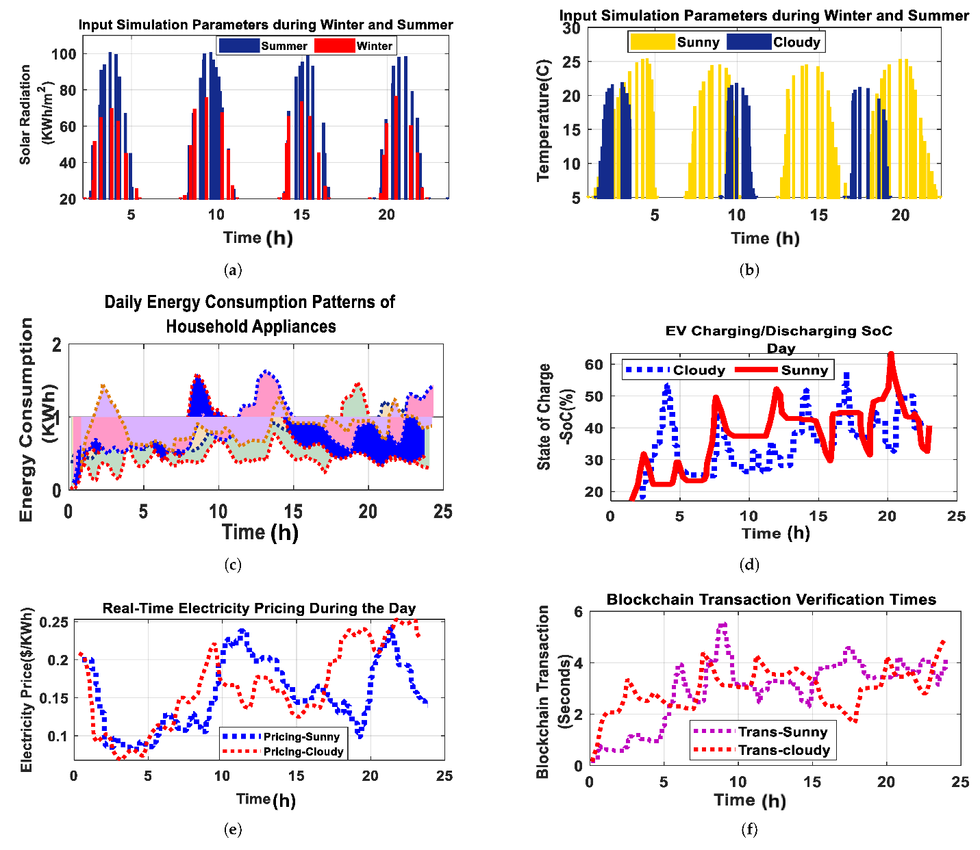
7: EXPECTED OUTCOMES AND LIMITATIONS
7.1 Expected Outcomes
The proposed AI-Based Smart Microgrid Energy Management and Load Balancing Platform is expected to achieve the following outcomes:
- Improved energy efficiency.
- Better electrical load balancing.
- Reduced electricity and operational costs.
- Increased utilization of renewable energy sources.
- Enhanced reliability and stability of the microgrid.
- Sustainable energy management.
- Better energy planning through AI-based forecasting.
- Reduced carbon emissions and environmental impact.
7.2 Limitations
Although the proposed system offers many benefits, it has some limitations:
- High initial installation and implementation cost.
- Requires reliable internet connectivity for cloud services.
- AI prediction accuracy depends on the quality of historical data.
- Regular maintenance of IoT devices and sensors is necessary.
- Cybersecurity threats may affect system performance.
- Renewable energy generation depends on weather conditions.
- Requires skilled personnel for system management and maintenance.
7.3 Future Enhancements
The proposed system can be improved in the future by adding the following features:
- Mobile application for remote monitoring and control.
- Integration with Electric Vehicle (EV) charging stations.
- Blockchain-based energy trading between users.
- Advanced AI models for more accurate demand forecasting.
- Smart home and smart building integration.
- Voice assistant support for system monitoring.
- Predictive maintenance using machine learning.
- Integration with smart city energy management systems.

CHAPTER 8: CONCLUSION
The AI-Based Smart Microgrid Energy Management and Load Balancing Platform is an innovative software solution that addresses the challenges of modern energy management. By integrating Artificial Intelligence (AI), Internet of Things (IoT), smart meters, renewable energy sources, battery storage, and cloud computing, the system enables efficient monitoring, forecasting, and optimization of electricity generation and consumption.
The proposed platform improves energy efficiency through AI-based demand forecasting, automatic load balancing, and optimized battery utilization. It also enhances the reliability of the microgrid, reduces electricity costs, increases the use of renewable energy, and supports sustainable energy management. The application of software engineering principles such as modularity, scalability, maintainability, reliability, usability, and security ensures that the system is flexible, dependable, and easy to maintain.
The Agile SDLC methodology provides an effective approach for developing the system by supporting continuous improvement, faster delivery, and easy adaptation to changing requirements. Although the system has some implementation challenges, such as high initial costs and dependence on quality data, its long-term benefits outweigh these limitations.
In conclusion, the proposed AI-Based Smart Microgrid Energy Management and Load Balancing Platform provides a reliable, intelligent, and sustainable solution for future energy management, helping organizations achieve better energy utilization, lower operational costs, and a greener environment.

